Energy Savings with Membrane Technologies in Wastewater Treatment
Geoffrey Johnston-Hallª, Barry Heffernanª, Steven Caoª, Kaushi Wijekoonª, Gerin Jamesª,
ª DuPont Water Solutions
*Corresponding author: Geoffrey.johnstonhall@dupont.com, +61 (2) 45770971

Abstract:
Wastewater treatment plants (WWTPs) are fundamental to addressing pollution of our environment and water ways, and are increasingly being considered for supplementing our water supplies through purification and reuse. However, WWTPs have a significant environmental footprint, reportedly consuming more than 2% of the world’s energy; contributing to a significant proportion of global greenhouse gas emissions, and a significant carbon footprint. [1]
Of the energy used by WWTPs, aeration is by far the largest energy sink; contributing to anywhere from 50-80% of total energy use. Aeration is essential to conventional and advanced wastewater treatment processes such as membrane bioreactors (MBRs); supporting rapid growth of microorganisms for organic matter digestion, and controlling fouling and performance in MBR through surface scouring. However, these aeration processes suffer significant energy losses through poor oxygen and energy transfer. Therefore, WWTP operators and technology providers have focused considerable attention on optimising aeration processes by improving operating processes, [1] controls systems, [2] product designs, [3] and aeration technologies. [4]
Advances in MBR aeration efficiency have been particularly significant, with aeration energy for MBRs becoming more competitive with conventional activated sludge (CAS) processes. While MBRs still generally use more energy than CAS processes, improvements to this technology has shifted the focus for membrane technology providers away from just improving the membrane process energy efficiency, onto improving the total biological treatment process aeration efficiency.
In this paper we will review and discuss the impacts of product and plant designs, and pulsed aeration improvements on MBR energy usage and carbon footprints, giving examples from some MBR plants around the world. In addition, we will also touch on some emerging membrane technologies being used to provide further energy savings in WWT; such as membrane aerated bioreactors (MABR).

Figure. Historical improvement of MBR energy demand over time is compared to the ‘typical’ energy demand range for conventional activated sludge (CAS) processes.
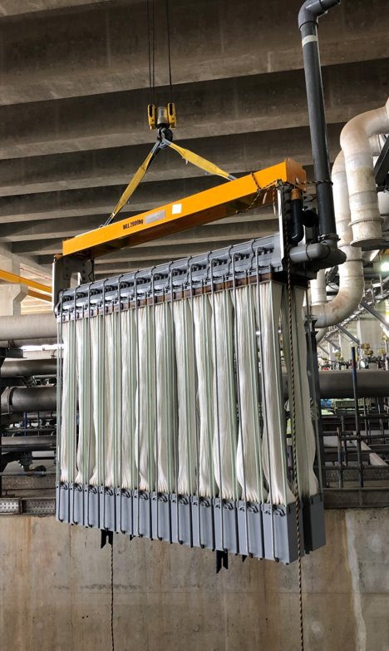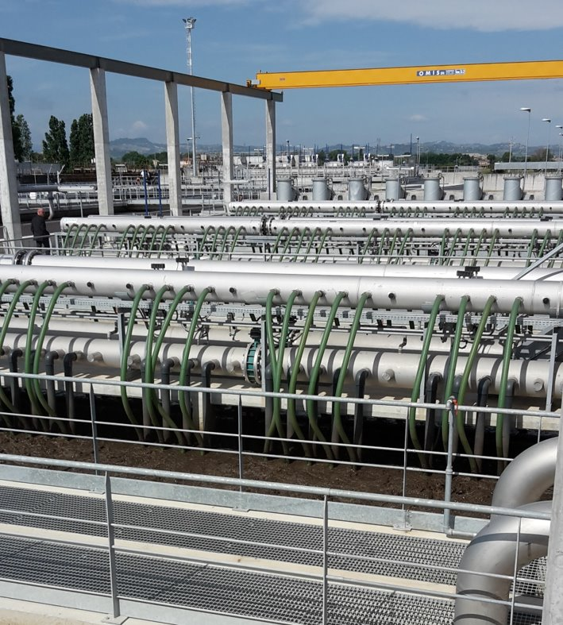
Figure. Photos of (left) MemPulse MBR modules being installed in China, and (right) a membrane operating system (MOS) tank in operation in Italy.

[1] | K. Ekici, Energy Saving Preventions for Aeration Process in Wastewater Treatment Plant, 2017.
[2] | Y. Chen, H. Zhang, Y. Yin, F. Zeng and Z. Cui, "Smart energy savings for aeration control in wastewater treatment," Energy Reports, pp. 1711-1721, 2022.
[3] | T. Miyoshi, T. P. Nguyen, T. Tsumuraya, H. Tanaka and T. Morita, "Energy reduction of a submerged membrane bioreactor using a polytetrafluoroethylene (PTFE) hollow-fiber membrane," Frontiers of environmental science & engineering, vol. 12, no. 3, 2018.
[4] | "Siemens' pulsed-air MBR reduces operating costs," Membrane Technology, p. 3, November 2008.

Keywords: MBR, Pulsed Aeration, Wastewater Treatment, Membranes

Presenting author details
Full name: Geoffrey Johnston-Hall
Email: Geoffrey.johnstonhall@dupont.com
Contact number: 0424092949
Affiliation: DuPont Water Solutions
Topic name / number:
Category preferred: Oral presentation
Would you like to be considered for a presentation award (Student and ECR only, please check eligibility on www.imstec2022.org)?: No

